**Worksheet**

**EXPERIMENT – 4**

**Yash Gupta**

**20BCS5009**

## Aim:

Perform Speech-to-text conversion using pre trained machine learning API models for short-form or long-form audio.

## Requirements:

PC with internet connectivity, Python 3.7

## Program:

# Python program to translate

# speech to text

import speech_recognition as sr

import pyttsx3

# Initialize the speech recognizer with microphone

r = sr.Recognizer()

# Function to convert speech to text

def SpeakText(command):

# Initialize the engine

engine = pyttsx3.init('dummy')

engine.say(command)

engine.runAndWait()

# Loop infinitely for user to speak

text_length=0

# It will going to continue run until it count the text length less than 10.

while(text_length<10):

# Exception handling to handle

# exceptions at the runtime

try:

# use the microphone as source for input.

with sr.Microphone() as source2:

# wait for a second to let the recognizer

# adjust the energy threshold based on

# the surrounding noise level

r.adjust_for_ambient_noise(source2, duration=0.2)

#listens for the user's input

audio2 = r.listen(source2)

# Using google to recognize audio

MyText = r.recognize_google(audio2)

MyText = MyText.lower()

print("Message: \n"+MyText)

SpeakText(MyText)

text_length=len(MyText)

print(text_length)

except sr.RequestError as e:

print("Could not request results; {0}".format(e))

except sr.UnknownValueError:

print("unknown error occured")

## Output:

If voice is recognized 🡪

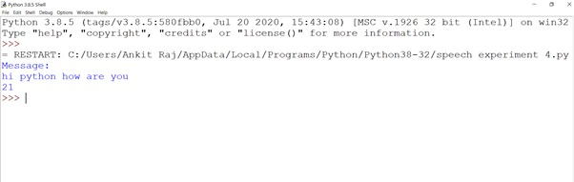

If voice is not recognized 🡪

